MongoDB(v3.4) Setup Guide For ITA

# 1. Material (Please copy/clone to your PC first)

## 1.1. Training PPT

Clone from github:

|  |
| --- |
| https://github.com/yellowb/full-stack-web-course.git |

You can find them in **\full-stack-web-course\db\mongodb\2017\materials**

You can also access the homepage of MEAN course:

|  |
| --- |
| https://github.com/yellowb/full-stack-web-course |

## 1.2. Tools

All materials are placed in here: \\HUANGYE-3-W7\mongoDB

## （1）MongoDB v3.4 Installation For Win x64：

\setup\mongodb-win32-x86_64-2008plus-ssl-3.4.5-signed.msi

## （2）Mongo Booster (GUI tool to manage MongoDB)：

\setup\mongobooster-3.5.6.exe

## （3）MongoDB Server startup config & script：

\setup\Script\

## （4） Reading：

<1> Official Document: <https://docs.mongodb.com/manual/>

<2> <<MongoDB definitive guide>>：\book\

# 2. Install MongoDB v3.4 on Windows

### 2.1. MongoDB Installation on your local PC

Run “mongodb-win32-x86_64-2008plus-ssl-3.4.5-signed.msi”

Suppose the Installation location is

|  |
| --- |
| C:\Program Files\MongoDB\Server\3.4 |

### 2.2. Copy the scripts to Installation location

Copy Below files from \setup\Script\ to C:\Program Files\MongoDB\Server\3.4\bin

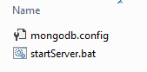

mongodb.config is the startup configuration and another is the executable startup script

### 2.3. Create Folder for MongoDB Server to store data

Please Create 2 folders：

（1）C:/mongoData/data

（2）C:/mongoData/logs

You can place the folders at other location if you want，but you must keep them updated in mongodb.config：

|  |
| --- |
| storage:  dbPath: "C:/mongoData/data"  journal:  enabled: true  engine: "wiredTiger"  wiredTiger:  engineConfig:  cacheSizeGB: 4  journalCompressor: snappy  directoryForIndexes: true  collectionConfig:  blockCompressor: snappy  indexConfig:  prefixCompression: true  systemLog:  traceAllExceptions: true  destination: file  path: "C:/mongoData/logs/mongodb.log"  logAppend: false  net:  port: 27017 |

### 2.4. Try to startup MongoDB

Use a command tool（eg. CMD in windows），switch to the Installation location（C:\Program Files\MongoDB\Server\3.4\bin）and run startServer.bat .

If you can see below logs, it startup successfully.

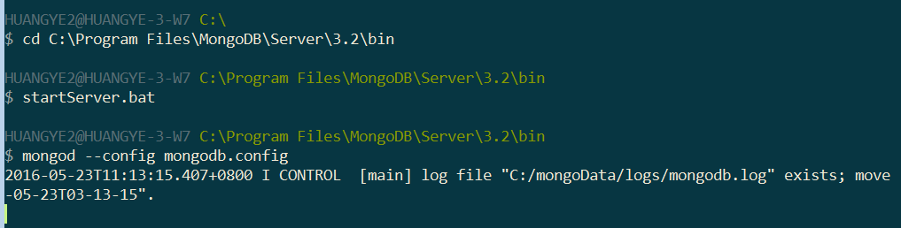

And you can also find the logs in log path（C:/mongoData/logs/）：

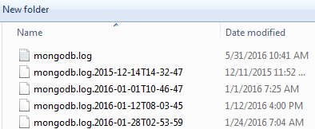

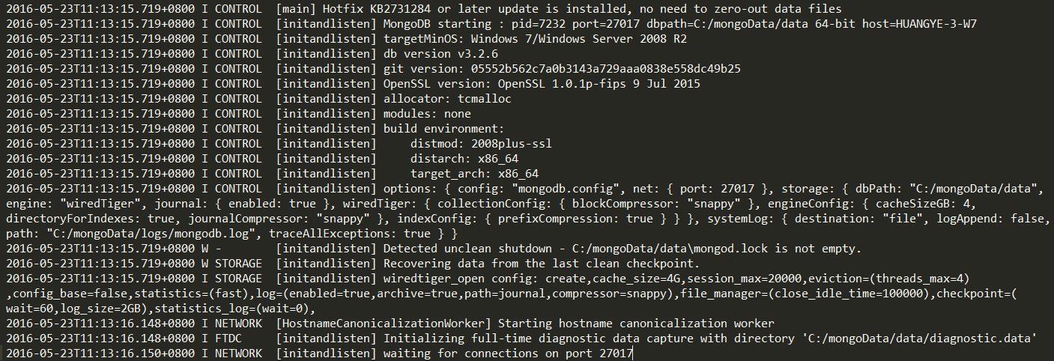

# 3. Install Mongo Booster

### 3.1 Installation

Run “mongobooster-3.5.6.exe”

### 3.2 Connect to MongoDB Server on your local PC

（1）Create a Connection first.

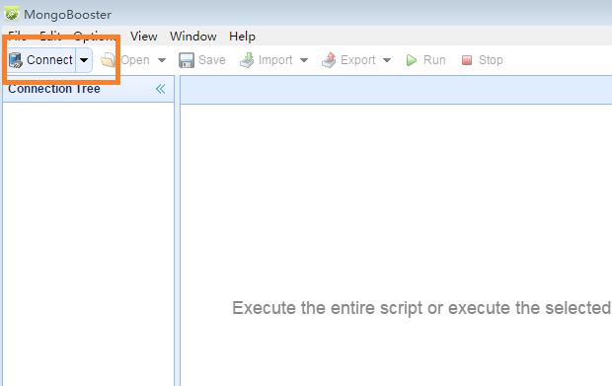

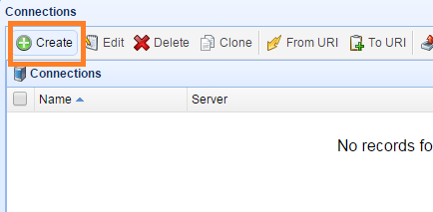

（2）Input the arguments like this：

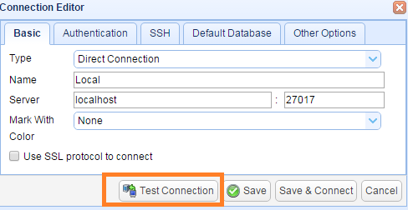

（3）Test the Connection，If ok，click “Save & Connect”

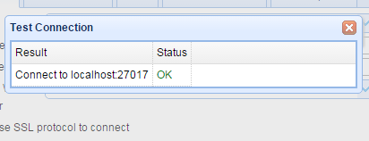

（4）You can Create a Database：

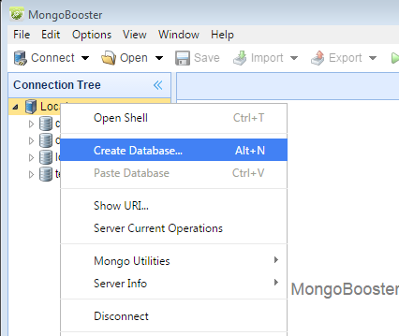

（5）Open the shell and insert some data into collection “test”，you don’t need to create it before.

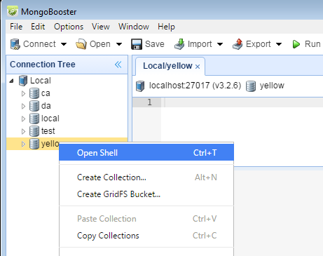

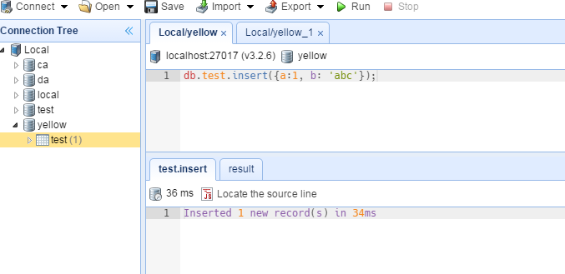

（6）Double click the “test” collection on the left, then you can see the data(You can switch to “Table View” easy to read):

